# Performance report

Environment Used to develop

* Visual Studio Code

-Visual studio Code is a code editor

PHP and HTML

-Php and HTML are both coding languages used to develop this website

* Xampp control panel

Apache

MySQL (SQL Database)

Movie Database

* Web Browser

Chrome

Internet explorer

Microsoft edge

* Text editor

Word

Notepad

Notepad++

Code optimizations

* Code optimization is a process of changing or modifying software to it more efficient, improving the system’s efficiency by making the system to use less resources (Processor or memory) which results in a faster machine and freeing up the resources to be used by another process.
* Optimization is also referred to as a transformation technique, using low-level programing to be more efficient, there are many ways to optimize programs including;

- The use of algorithms

-

- Machine-independent Optimization

In Machine optimization the compiler takes the code and edits parts of the code that do not involve any CPU register. (example)

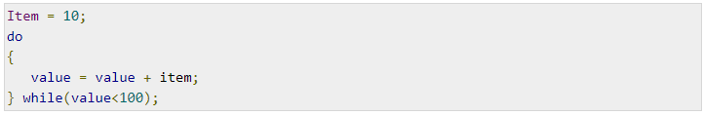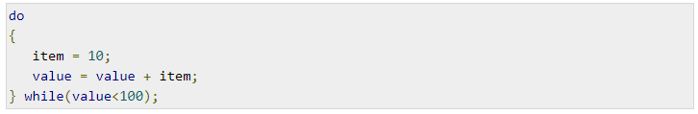

Machine-dependent Optimization

* Machine dependent optimization, is done once the code has been compiled and changed according to the target machine hardware, the use of the CPU register allows for absolute memory reference allowing for the optimizer to take full advantage of the memory hierarchy.

Performance tools

|  |  |
| --- | --- |
| Tools |  |
| - **Php_Code** sniffer is a set of scripts that read through php code and detects any errors or violation with against the pear code standard and fixes them accordingly, the use of code sniffers in development can be very useful for keeping code clean and consistent. |  |
| -**WebPageTets.org** is a website performance tool that tests speeds from multiple location around the world using consumer browsers, testing results provided detailed diagnostics like page speeds and recourse loading charts. |  |
| -is an application used for testing web or server based applications, once this tool has analyzed the website it identifies changes that can be made to increase efficiency. | **C:\Users\student\Documents\Capture.PNG** |

.